Transition of microfinance organizations to international financial reporting standards

From 1 January 2021, in accordance with the Law of the RK “On amendments and additions to some legislative acts of the Republic of Kazakhstan on issues of the restoration of economic growth” (p. 36 A. 1) the activity of organizations engaged in microfinance activities (hereinafter – MFO) refers to financial services.
According to the Law of the Republic of Kazakhstan “On Accounting and Financial Reporting”, organizations providing financial services must maintain accounting records and prepare financial statements in accordance with International Financial Reporting Standards (hereinafter – IFRS) and regulatory legal acts of the National Bank of the Republic of Kazakhstan on the issues of accounting and financial reporting (part 2 of the p 4, A 2). Therefore, microfinance organizations must carry out comprehensive work on the transition to IFRS and the application of regulatory legal acts of the National Bank of the Republic of Kazakhstan on accounting and financial reporting.
The regulatory legal acts of the National Bank of the Republic of Kazakhstan on the regulation of the activities of microfinance organizations on the issues of accounting and financial reporting include:
- General chart of accounts for individual subjects of the financial market of the Republic of Kazakhstan, approved by Resolution No. 79 of the Board of the National Bank of the Republic of Kazakhstan dated September 22, 2008;
- Instructions on accounting by specific entities of financial market,
approved by Resolution No. 68 of the Board of the National Bank of the Republic of Kazakhstan dated July 1, 2011;
- Rules for the presentation of financial statements by financial Organizations and Organizations Engaged in Microfinance Activities, approved by Resolution No. 41 of the Board of the National Bank of the Republic of Kazakhstan dated January 28, 2016;
- Rules of automation of accounting, approved by the Resolution of the Board of the National Bank of the Republic of Kazakhstan dated March 27, 2017 No. 47.
In transition to IFRS, microfinance organizations must be guided by the standards of IFRS 1 “First Application of IFRS” (hereinafter referred to as IFRS 1).
In accordance with paragraph 21 of IFRS 1, an entity's first financial statements under IFRS must include at least:
- three statements of financial position;
- two statements of profit or loss and other comprehensive income;
- two separate statements of profit or loss (if any);
- two statements of cash flows;
- two statements of changes in equity,
and related notes, including comparative information for all the statements presented.
Thus, schematically, the reporting process for the transition to IFRS is as follows (Figure 1):
Figure 1. Preparation of MFO reports during the transition to IFRS

In general, the process of transition to IFRS for MFOs provides for:
- Development of the accounting policy of the MFO - determination of the principles that will be used in the preparation of financial statements in accordance with IFRS.
- Determination of the need to apply the “voluntary” exceptions provided for in paragraph D1 of IFRS 1.
- Applying the “mandatory” exceptions described in paragraph B1 of IFRS 1.
- Preparation of the opening report (balance sheet) on the date of transition to IFRS.
When preparing an opening statement of financial position under IFRS, with the exceptions set out in paragraphs 13-19 and Annexes B-E of IFRS 1, MFOs must:
- recognize all assets and liabilities that are required to be recognized under IFRS;
- do not recognize items as assets or liabilities if IFRS do not allow such recognition;
- reclassify items that, in accordance with previously applied generally accepted accounting principles (hereinafter-GAAP), has been recognized as a type of asset, liability or component of equity, but are a different type of asset, liability or component of equity under IFRS; and
- apply IFRS to the measurement of all recognized assets and liabilities.

An example of a step-by-step transition to IFRS for MFOs is shown in Figure 2.
Figure 2. Example of the stages of transition to IFRS
Development of accounting policy
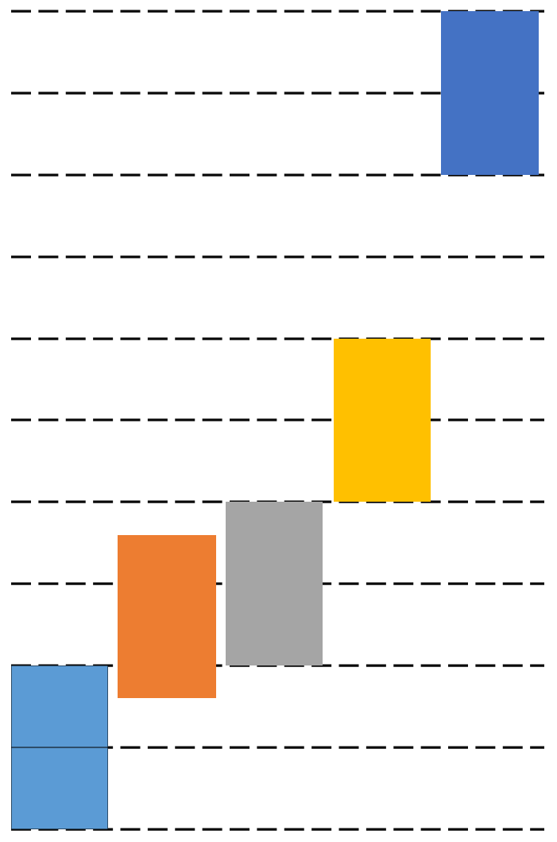
Loss allowance Methodology
application of IFRS

Introductory report (balance sheet)
Accounting in accordance with the current GAAP*
Quarterly reporting
1st quarter of 2021 | 2 quarter of 2021 | 3 quarter of 2021 | 4 quarter of 2021 | 1st quarter of 2022
 | Development of accounting policy
 | Developing methodology for loss allowances
 | Preparation of the incoming balance sheet (introductory report)
 | Submission of quarterly financial statements to the territorial branch of the National Bank at its location in accordance with the forms specified in Appendices 14 and 16 of the NBRK Act No. 41 of 28.01.2016
 | Accounting and reporting of all transactions and events from 01.01.2020 and onwards in accordance with the provisions of the newly approved Accounting Policy and IFRS
* | GAAP – previously applied accepted accounting principles
Accounting policy
- Both in preparing the introductory statement of financial position under IFRS and for all periods presented in its first financial statements under IFRS, a microfinance organization shall use the same accounting policy (paragraph 7 of IFRS 1).
- The accounting policies must comply with the requirements of each IFRS effective as of the end of its first reporting period under IFRS, except as specified in paragraphs 13-19 and Annexes B-E.
- The accounting policies applied in the preparation of the opening statement of financial position under IFRS may differ from the accounting policies under previously applied GAAP at the same date. The resulting adjustments relate to events and transactions that occurred prior to the date of transition to IFRS. These adjustments shall be recognized directly in retained earnings (or, if appropriate, in another category of equity) at the date of transition to IFRS.
Methodology for loss allowances
In accordance with the paragraph 6 of article 250 of the Tax Code of the Republic of Kazakhstan microfinance organization (with the exception of pawnshops and loan associations) have the right to refer to deduct expenses for creating provisions (reserves) against bad and doubtful assets for granted microloans, the value of which is determined by the Provisioning methodology corresponding with IFRS (IFRS) 9.
Preparation of the opening statement of financial position under IFRS
The opening statement of financial position under IFRS is the starting point for accounting under IFRS.
When forming the opening statement of financial position, the company is required to make the adjustments provided for in IFRS 1.
Thus, at the date of transition to IFRS, the inputs to List of turnovers and transactions by accounts are recalculated and a transformation table is compiled.
In accordance with paragraph 9 of IFRS 1, the transitional provisions in other IFRSs apply organization already use IFRS when you make changes to your policy; they do not apply to changes implemented by the organization, first applying IFRS, except as described in appendices B–E.
Below are examples of accounting for property, plant and equipment, intangible assets (FA, IA) and financial assets/liabilities under IFRS
Accounting for fixed assets, intangible assets (FA, IA) in accordance with IFRS)
Microfinance organizations that have accounted for property, plant and equipment and intangible assets in accordance with IFRS for small and medium – sized businesses (hereinafter referred to as IFRS for SMEs) or national standards must be guided by IAS 16 “Property, Plant and Equipment” (hereinafter referred to as IAS 16) and IAS 38 “Intangible Assets” (hereinafter referred to as IAS 38), respectively, when switching to IFRS.
In accordance with paragraphs D5-D7 of IFRS 1, the MFO reserves the right to measure an item of property, plant and equipment and intangible assets at the date of transition to IFRS at fair value and to use the fair value of this item as its notional cost at that date, or to use the revalued amount under previously used GAAP determined at the date of transition to IFRS or earlier as the notional cost of this item at the date of revaluation. Provided that, at the date of the revaluation, the revalued amount was generally comparable:
(a) at fair value; or
(b) with an initial cost or amortized cost in accordance with IFRS, adjusted to reflect, for example, changes in a general or special price index.
Accounting for financial assets/liabilities under IFRS
Financial assets shall be measured for whether the asset meets the conditions of paragraph 4.1.2 or the conditions of paragraph 4.1.2 A of IFRS 9, based on the facts and circumstances existing at the date of transition to IFRS.
In turn, financial liabilities are assessed for compliance with the terms of paragraph 4.2.1 of IFRS 9.
As part of the accounting for financial assets and liabilities in accordance with IFRS 1, a microfinance institution must ensure that the provisions of IFRS 9 are applied retrospectively.
If the retrospective application of the effective interest method in IFRS 9 is impracticable for an entity (as defined in IAS 8), the fair value of a financial asset or financial liability at the date of transition to IFRS must be taken as the new gross carrying amount of such financial asset or the new amortized cost of such financial liability at the date of transition to IFRS.
At the same time, IFRS 1 allows for the recognition of financial assets and liabilities at fair value through profit or loss, provided that these assets and liabilities meet the criteria set out in paragraphs 4.1.5 and 4.2.2 of IFRS 9 at the transition date (D19 and D19A).
Conclusion
In view of the above, each MFO must independently develop a plan for the transition to IFRS, including the development of accounting policies, internal documents on the application of accounting policies to reflect all events and transactions carried out by the MFO. An important stage of the transition is also the preparation of information systems to meet the requirements of the Accounting Automation Rules.

An entity may decide to use one or more of the following exemptions: (a) share-based payment transactions (paragraphs D2 and D3), (b) insurance contracts (paragraph D4); (c) notional cost (paragraphs D5– D8B), etc.
Exceptions to the retrospective application of other IFRSs. The following exceptions are mandatory for the entity: (a) derecognition of financial assets and financial liabilities (paragraphs B2 and B3), (b) hedge accounting (paragraphs B4–B6); (c) non-controlling interests (paragraph B7), etc.

